**Caples Monitoring Metadata**

Folders in Caples Box

Agreements: This is a good place to store all the background information on agreements between with all the partners. This folder can also contain all objectives and prospectus.

Avian Monitoring: This folder will include all the output form the avian monitoring work.

Field Seasons: This folder will have all general information for each of the field seasons.

GIS: Probably a great place to store final GIS products.

Meetings: All agendas and notes from meetings will be stored in this folder.

Photos: This folder has all photos and videos that have been taken in the Caples area.

Vegetation Monitoring: This folder will include all the output form the vegetation monitoring work.

**More Information on Folders:**

Field Seasons

2020 – 2020 field season

Maps – Final maps used for the field season. These maps are spatial PDFs.

Vegetation – Prioritization and objectives of monitoring partners.

Vegetation Monitoring

Background – All supporting documents that were produced or utilized to develop the vegetation monitoring (e.g., Caples Ecological Assessment)

Data – This folder contains all the vegetation data that has been collected.

Mixed Conifer – All mixed conifer vegetation data

Data 2013 – raw data from 2013 data collection

Data 2017 – raw data from 2017 data collection

Data 2018 – raw data from 2018 data collection

Database Output – data that has been output from the Working Database folder in a format different than access

Datasheet Template – data templates for vegetation sampling

Red Fir – All red fir vegetation data

Field Seasons – data for upcoming and past field seasons for vegetation monitoring

Photos – all vegetation photos (probably will be merged in with the overall photos)

Protocols – all protocols for the mixed conifer and red fir monitoring

Questions:

Do we want to have a main GIS folder? Usually this would be on the T drive so maybe we only include shapefiles and general outputs?

Would we merge all of the FBAT data into one database?

Should we move aspen data into this folder?

Need the Survey 1,2,3 data templates for Caples

Need to add all of Scott’s data

Appendix A. Metadata for Access Database

Plot Description Metadata

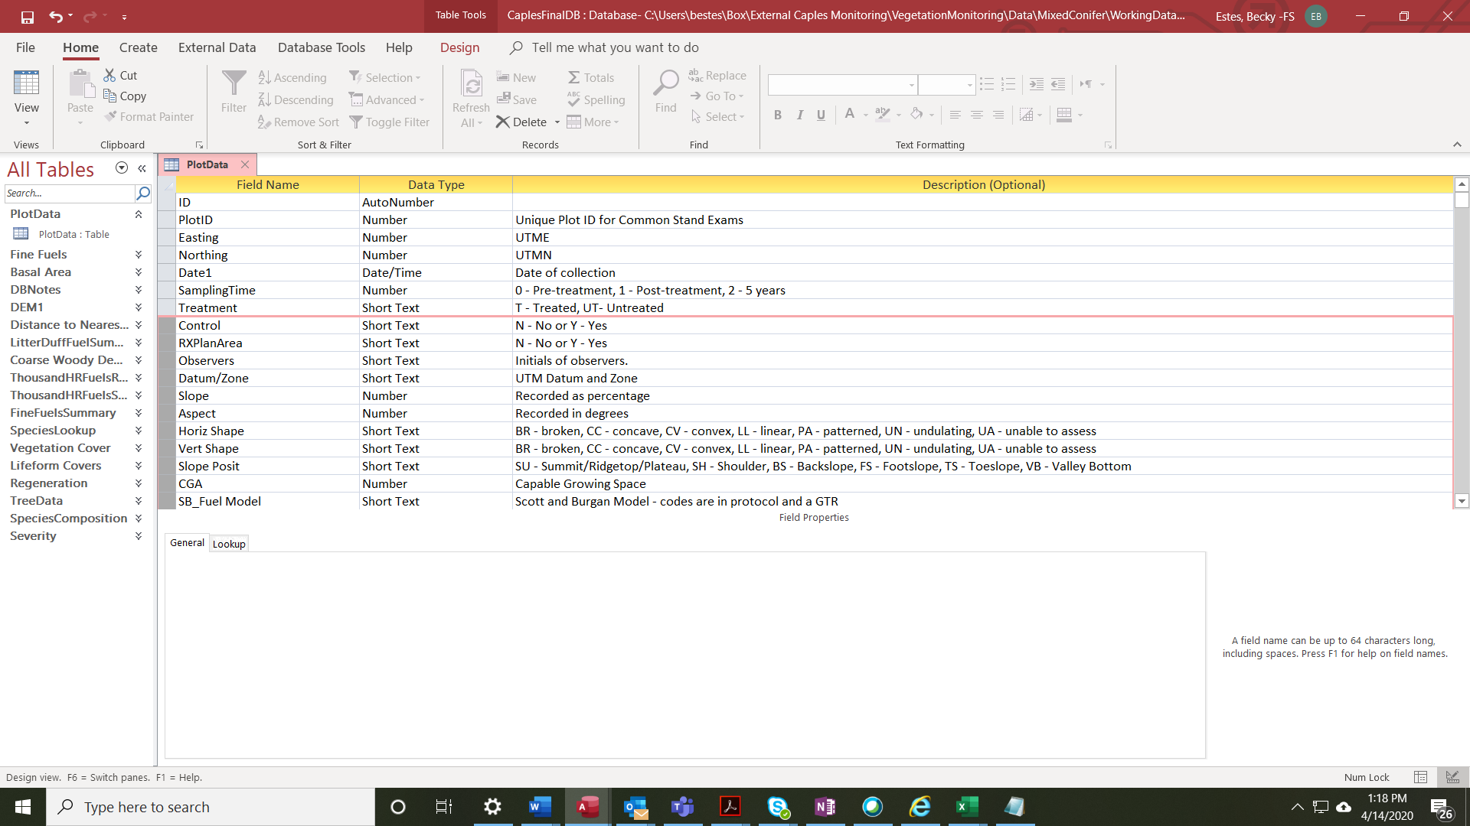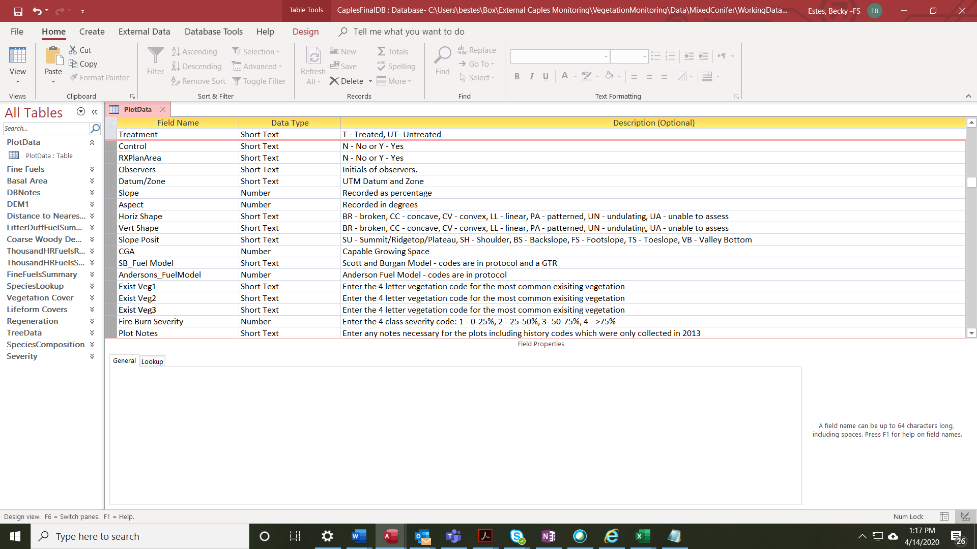

Vegetation Cover Metadata

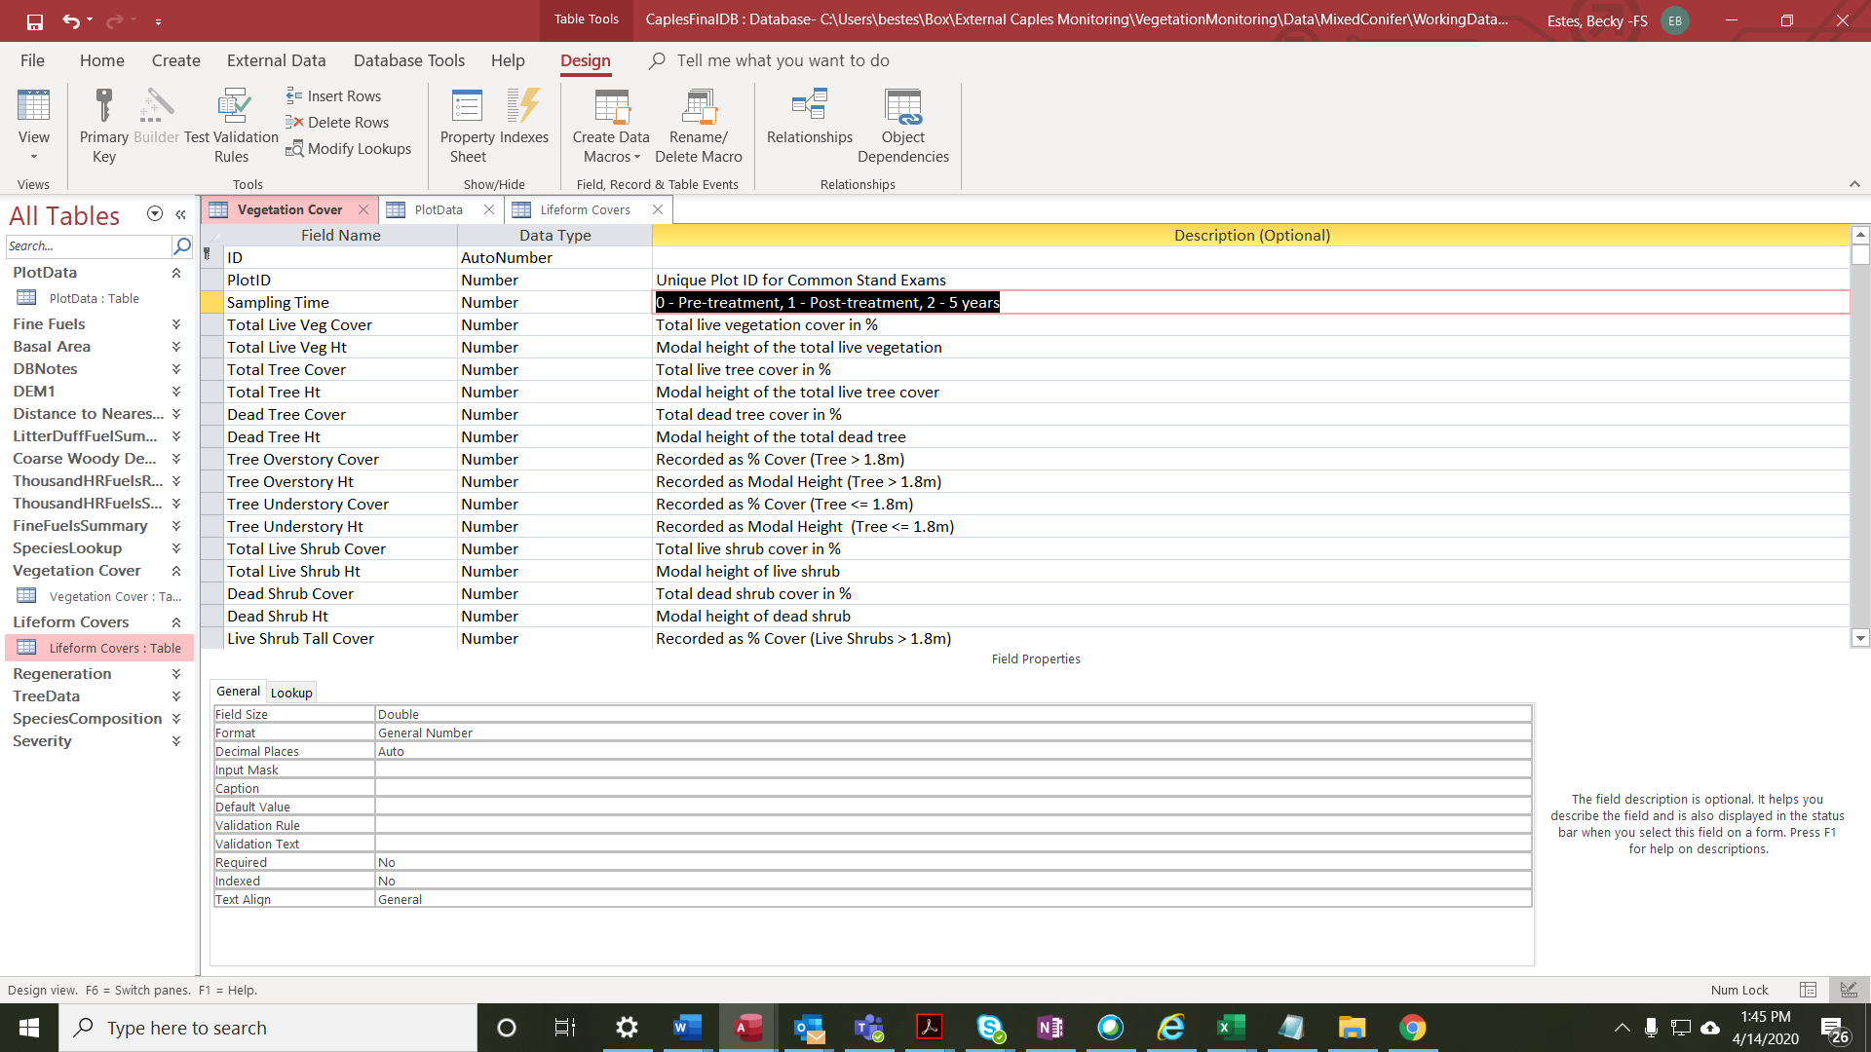

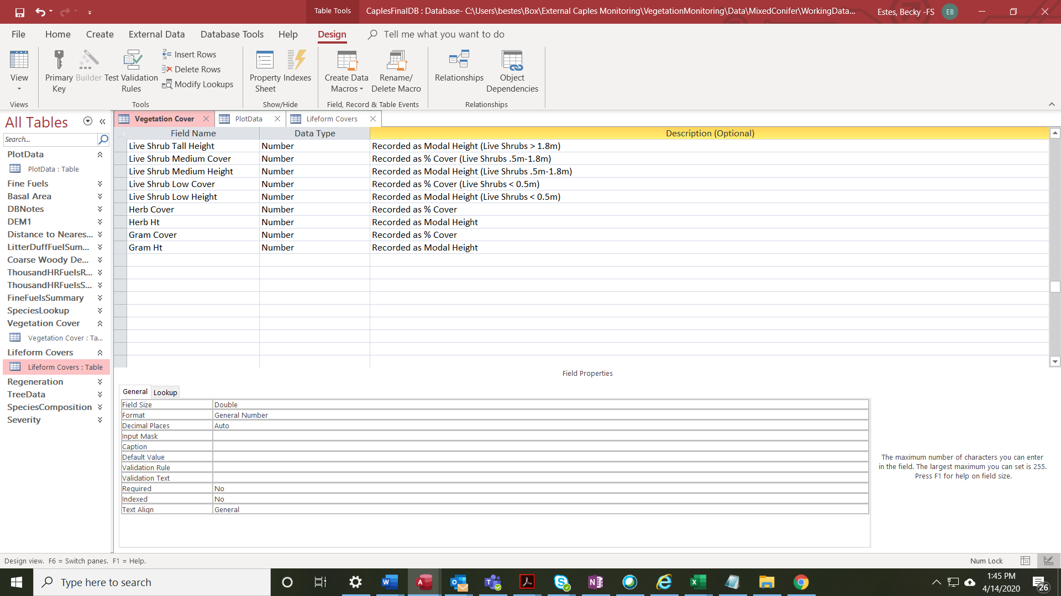

Lifeform Covers

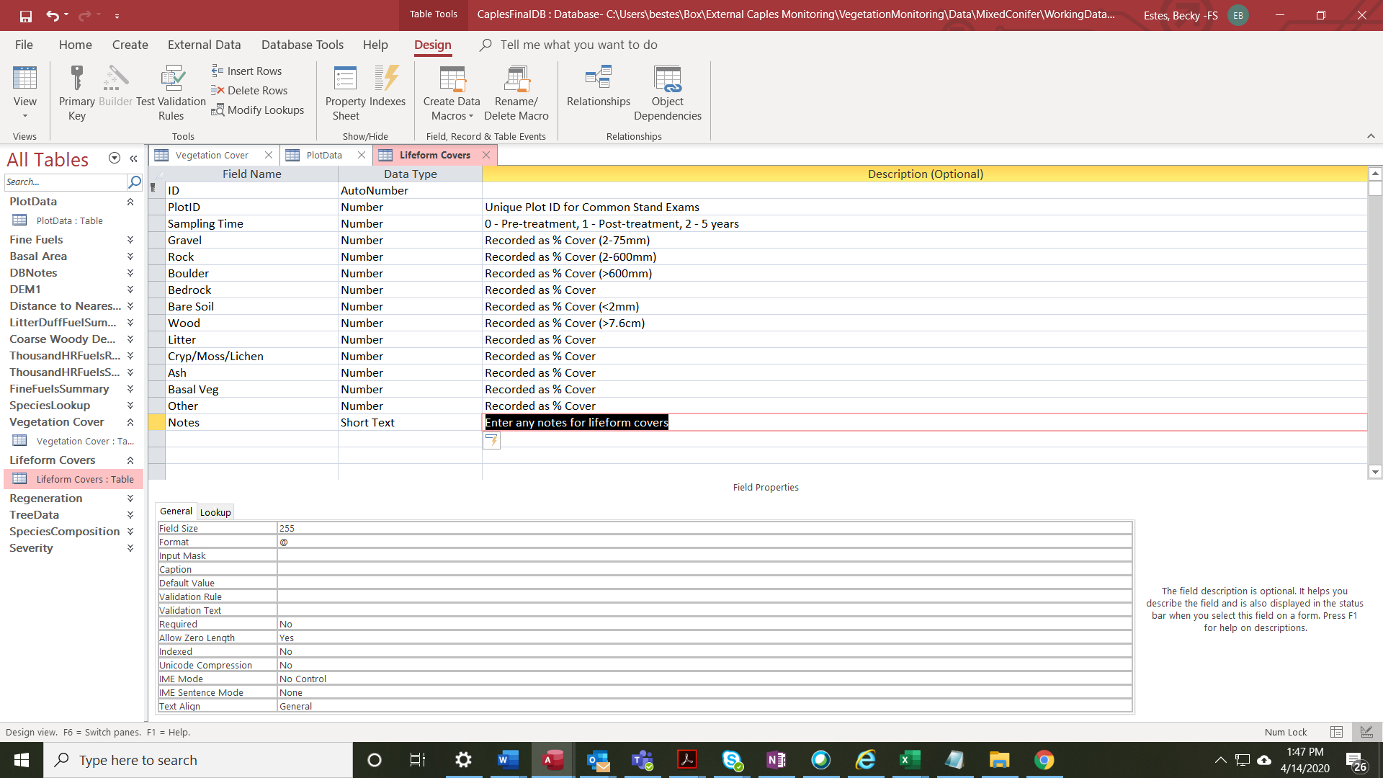

Regeneration

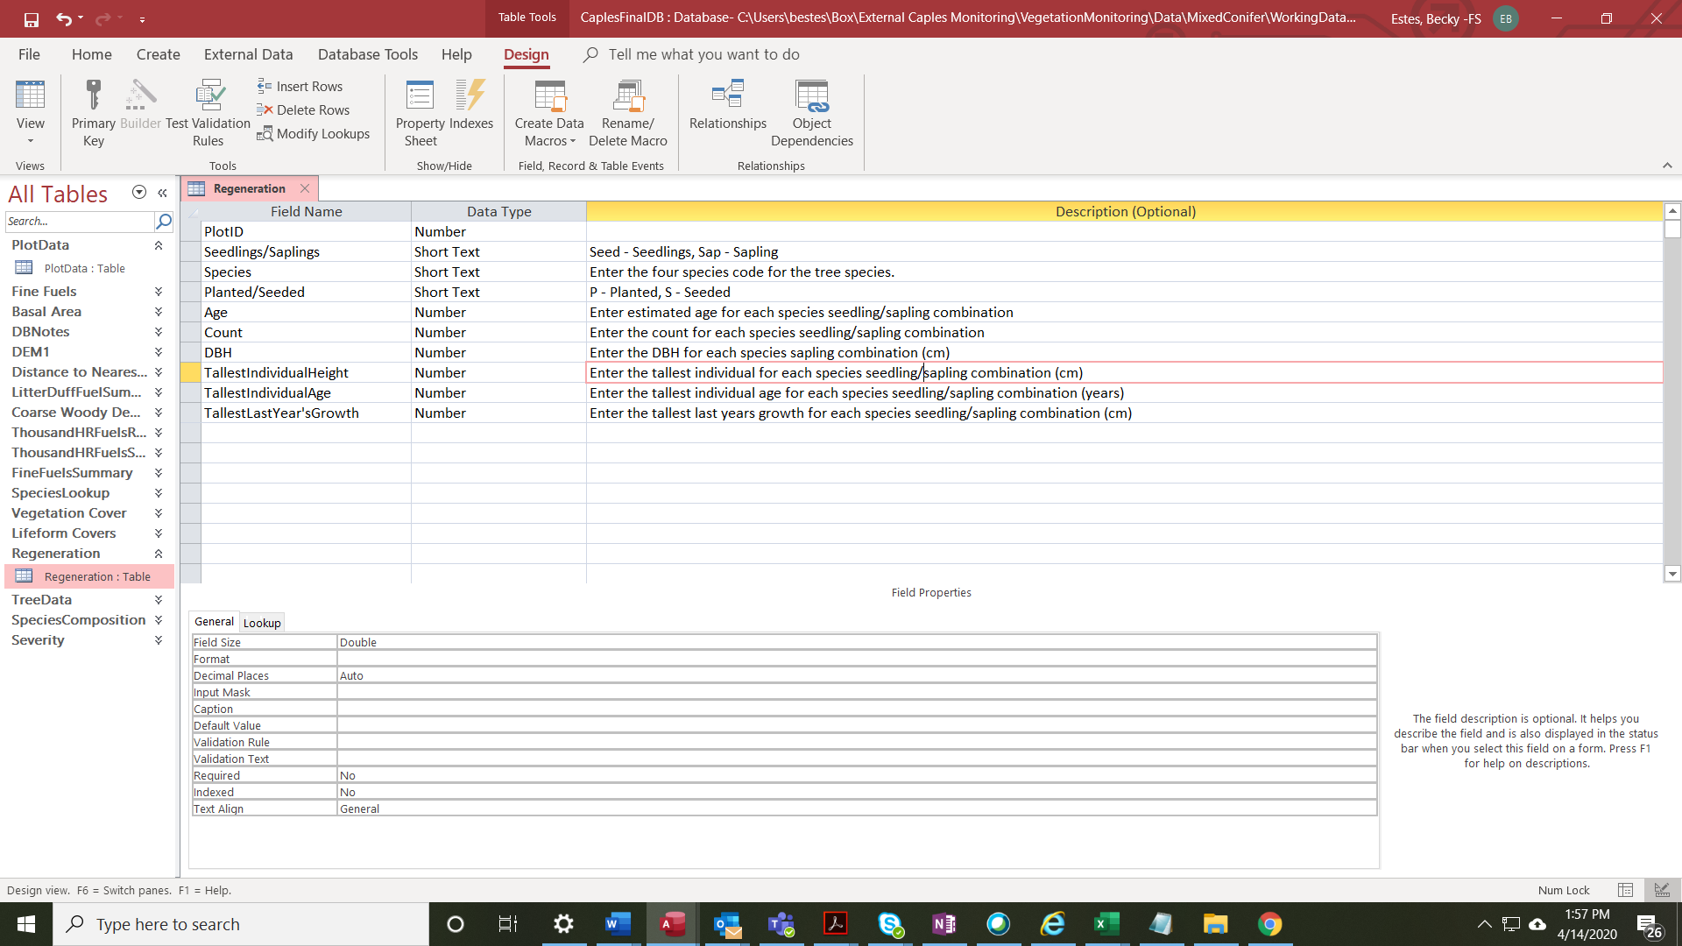

Fuels Data

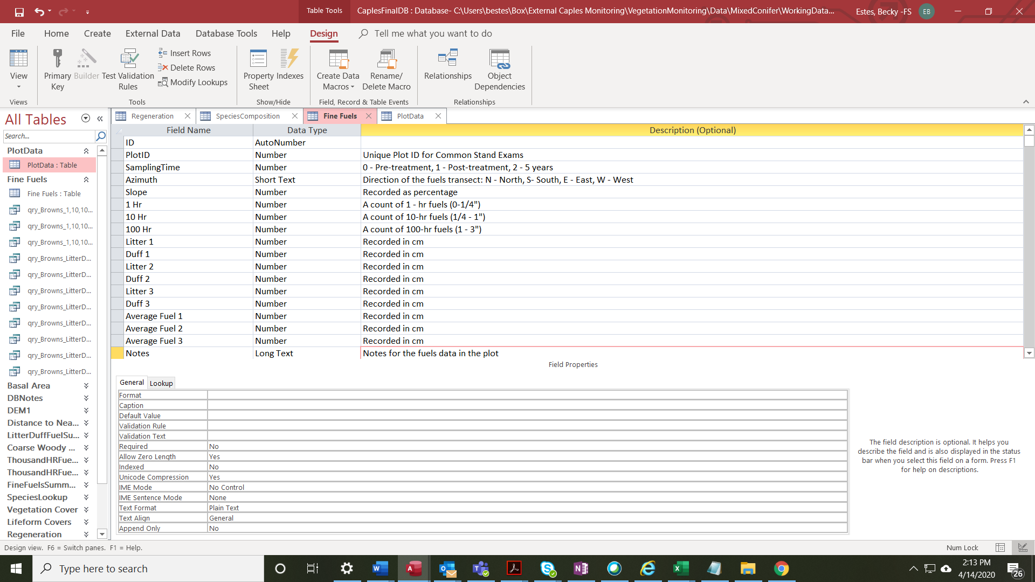

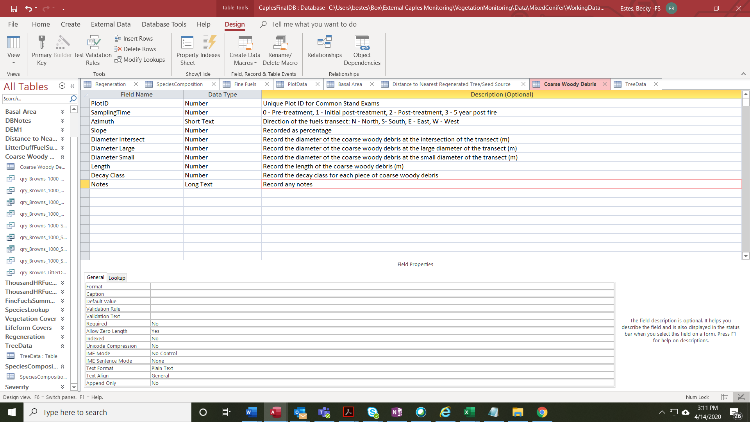

Basal Area

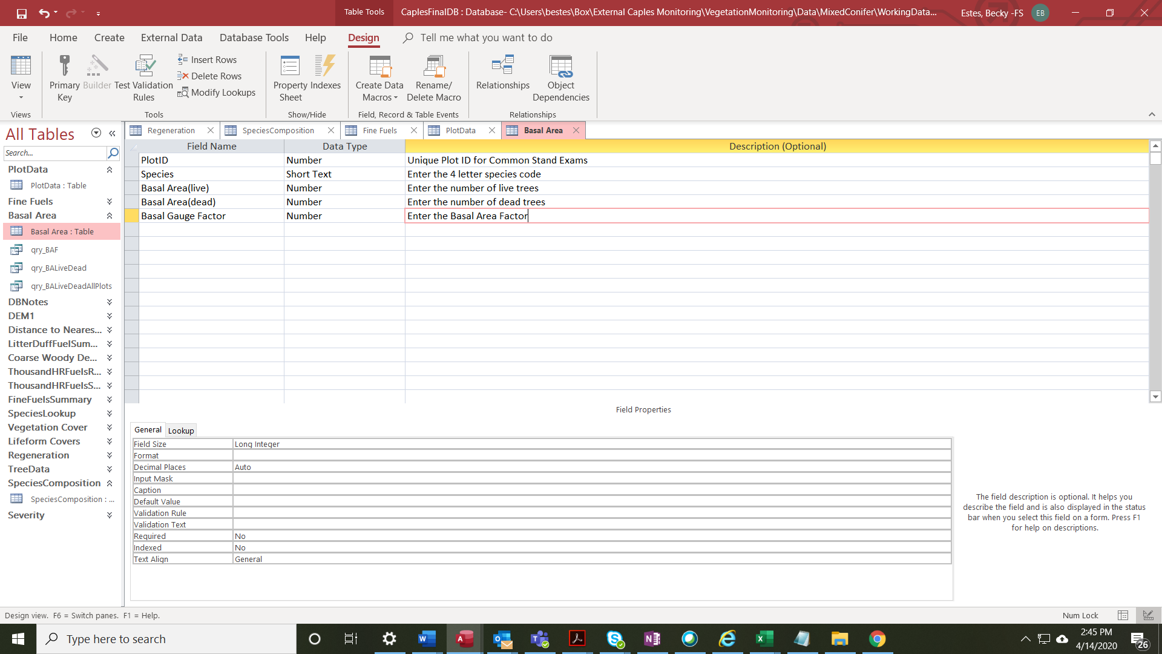

Distance to Seed Source and Regenerated Tree

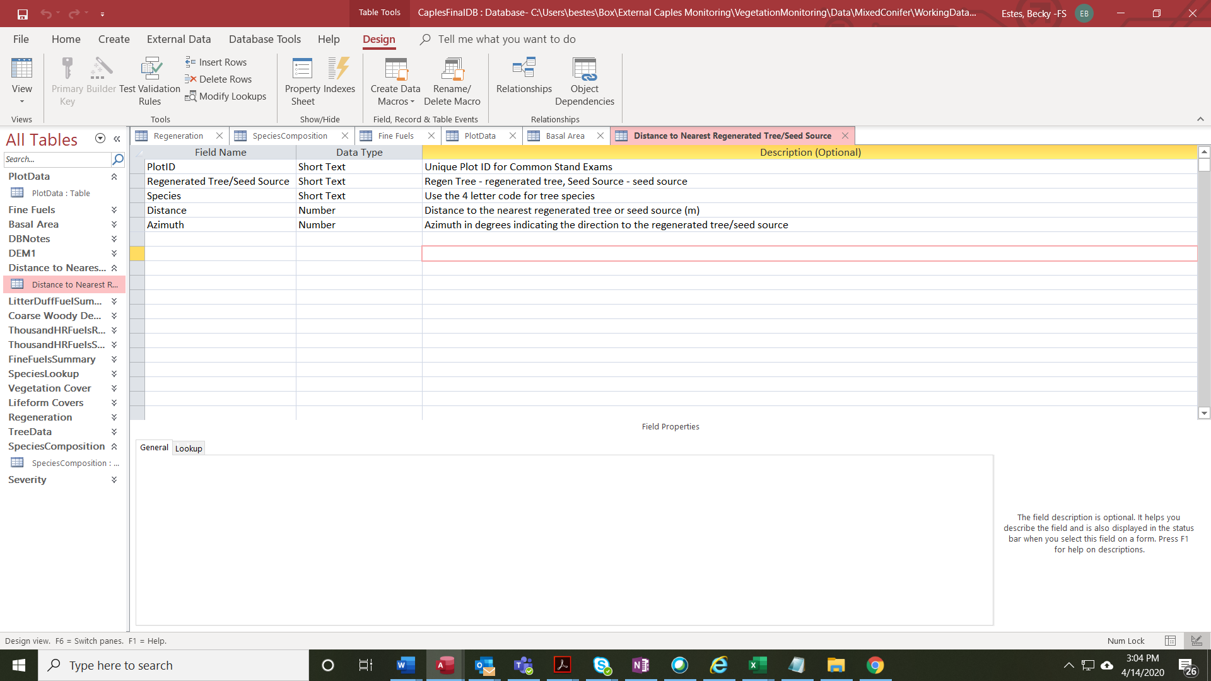

Species Lookup

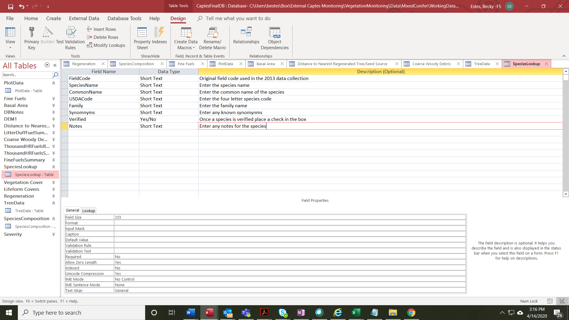

Species Composition

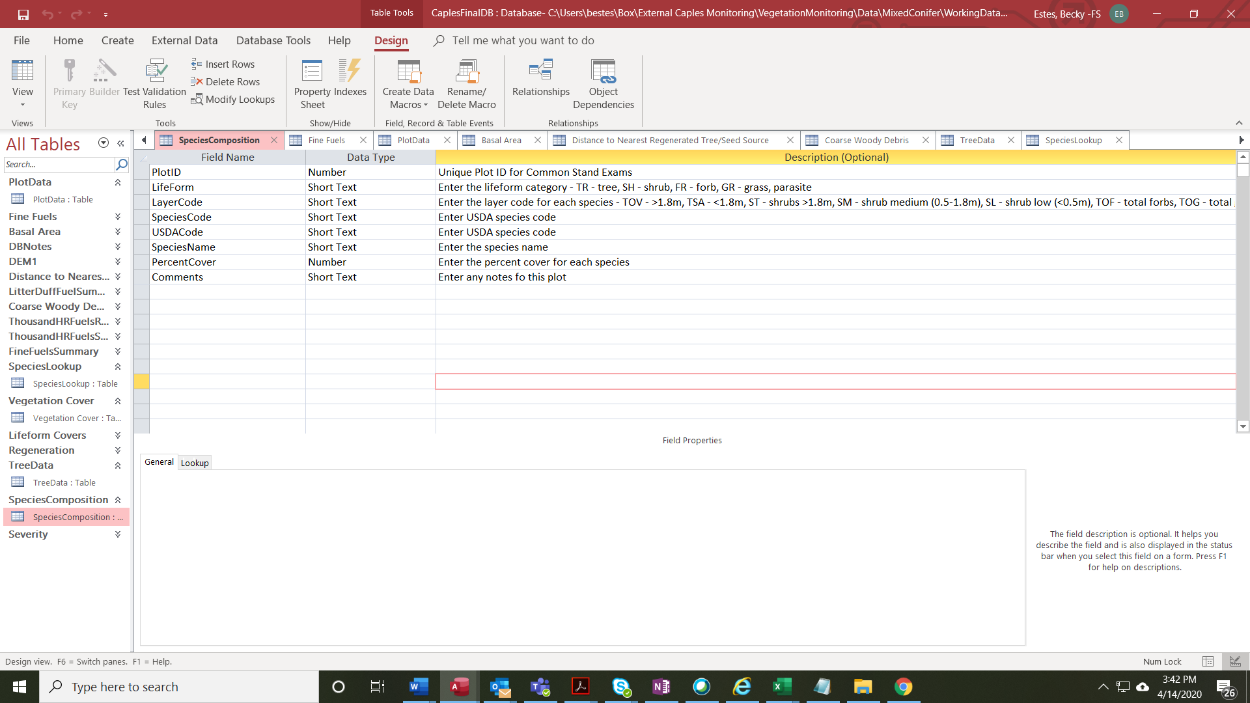

Tree Data

